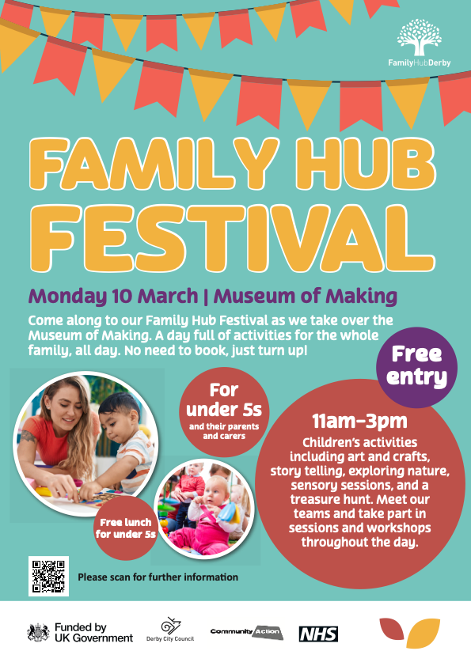
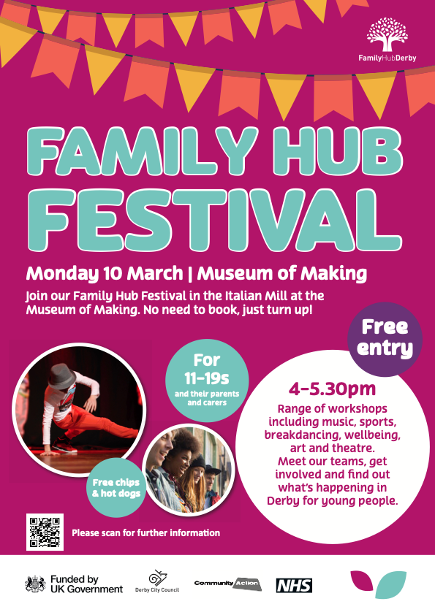
A recap on the ‘Family Hub Festival’ 2025

Understanding Family Hubs- Why we ran this event…
For many families, young people and children Family Hubs play an important part of everyday life! The programme is committed in supporting these families with children aged 0-19 or up to 25 for SEND and play an important part in providing access to the “right services, in the right place, at the right time”.
So why an event?!
The external providers within the Family Hubs have been highly successful and without their support the outcomes would be significantly different, therefore it called for a festival to celebrate their success achieved in the last year. It was also an opportunity for anyone in Derby to attend, whether it was individuals already familiar with Family Hubs or new people wanting to learn more about the support available in their local area. The more people to attend the better!
From 1st August 2023 to 31st December 2024 the numbers were amazing! We are hoping from this event it reached more people and these numbers increase!
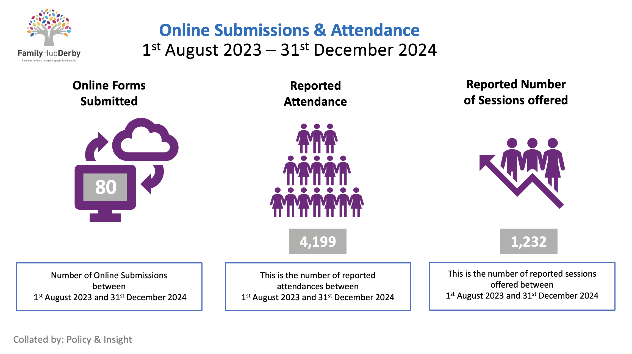

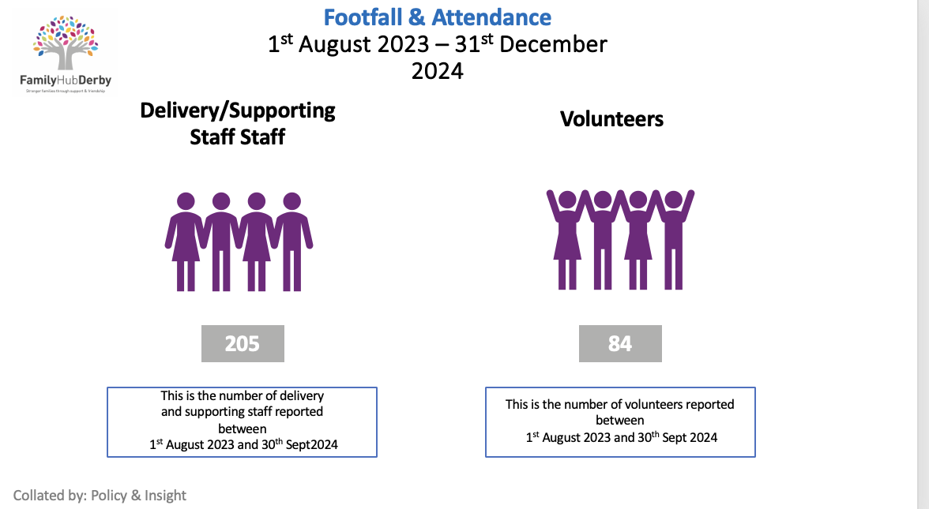

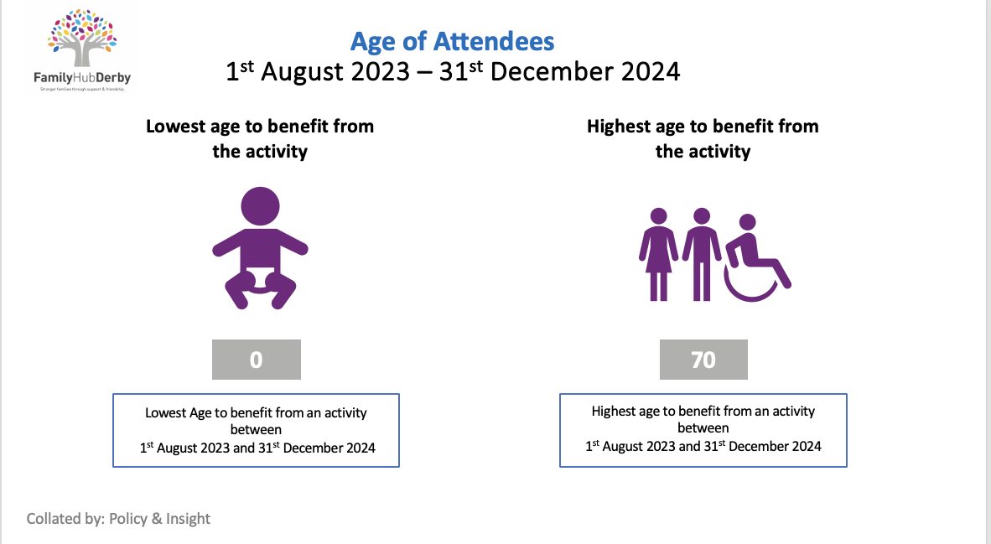

rs
How the day looked!
We had the amazing opportunity to hold the festival at the Museum of Making and had access to the entire museum for all the families to explore and enjoy!

The Museum café was also open for all families to enjoy a free lunch for under5’s and chips/hot dogs later in the day!
From 9:30 to 10:30 an invited audience delivered in celebrating PEEP families in the Italian Mill, whilst our other partners were getting set up in the other spaces in the museum!
Then from 10:30 to 11:00, the family Hub activities and partners focussed on getting set up for the fun day ahead and to prepare for the public to arrive.
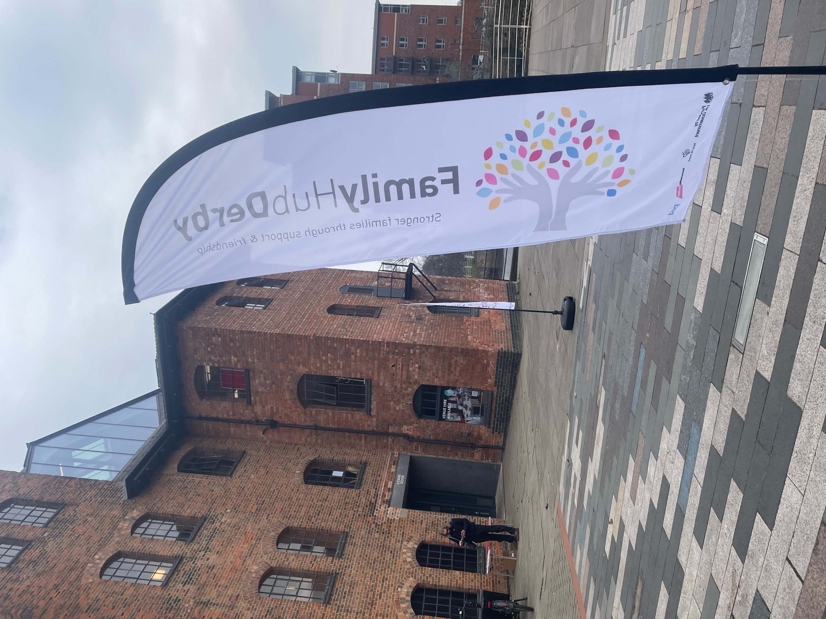
We opened the doors to the public from 11am to host our Family Hub Festival activities and our partners! Upon arrival there was huge lines of people to get inside, which was a great turnout for the day! It was great to see so many different families and young people attend for the first half of the day. I saw so many great conversations take place, and it was amazing to see how involved the families were. We ensured there was a space available for parents to store their pushchairs and matts

on the floor for the little ones to play. The different stalls we had across the museum were informative and were a great representation of how important their work is within Family Hub services is!
From 3:00pm we all worked together in the set-up of the second half of the event for the older youth activities in the Italian Mill. It was an amazing experience to see the success for the first half of the Family Hub Festival and we were hopeful that our half of the day would have a similar outcome.
It was me, Helen and Aliyah’s responsibility to ensure our activity partners had the appropriate space to set up their activities/workshops so that the event could run as smoothly as possible! Once we were ready to go it was time to open the doors!
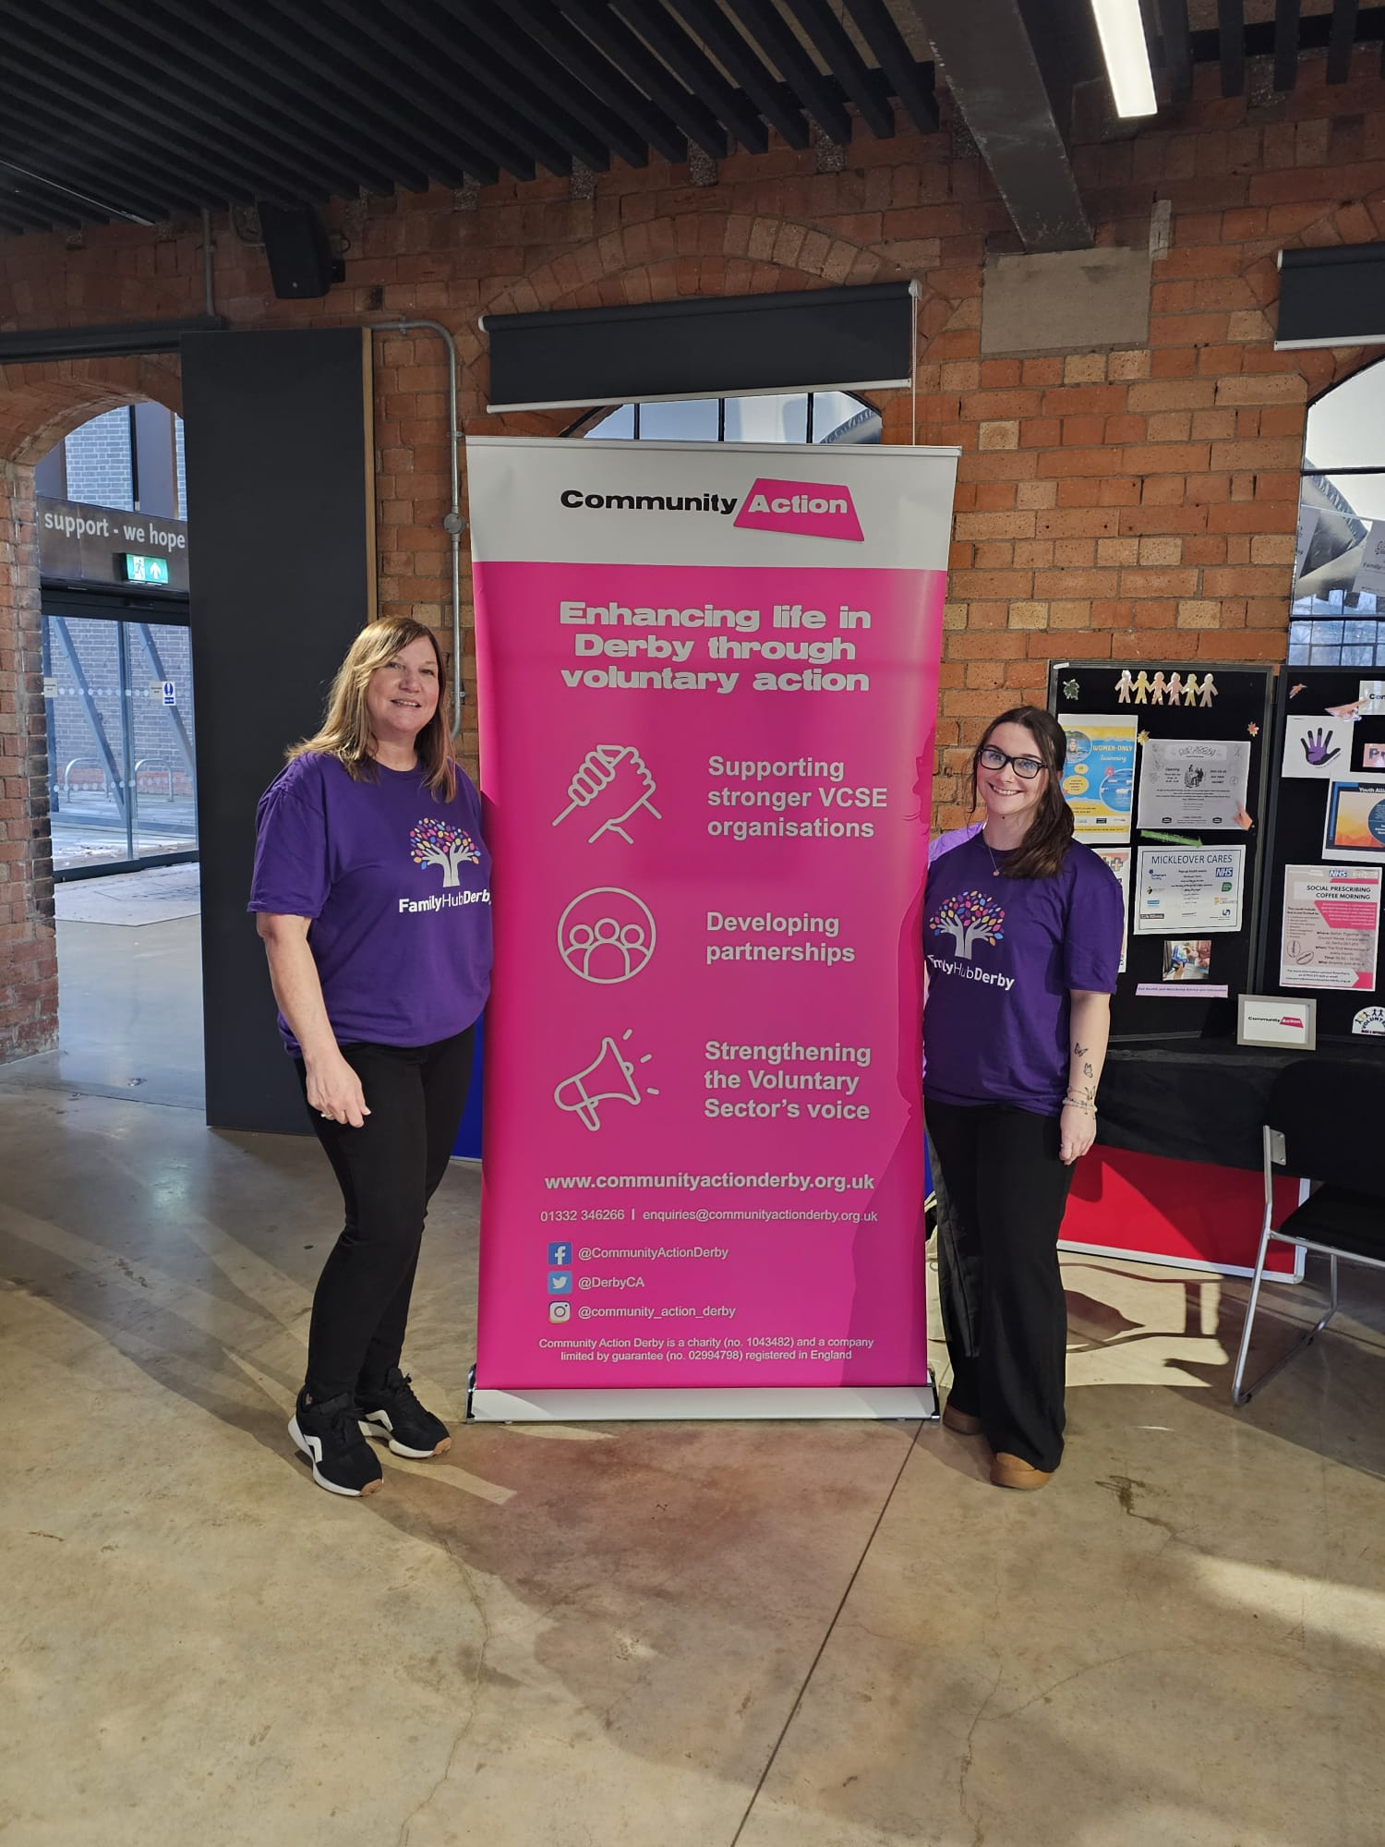
Me and Helen ready to go!

We had the pleasure of the following partners to attend and in delivering their activities/projects to our young people! 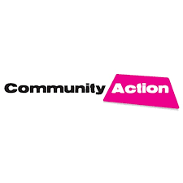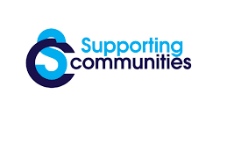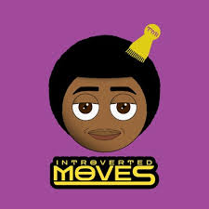
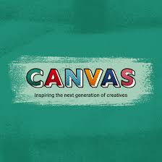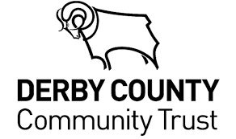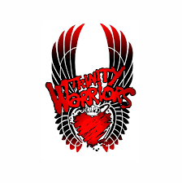

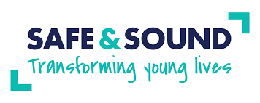

Thank you all for your attendance and in making this event possible, we could not have done it without you!

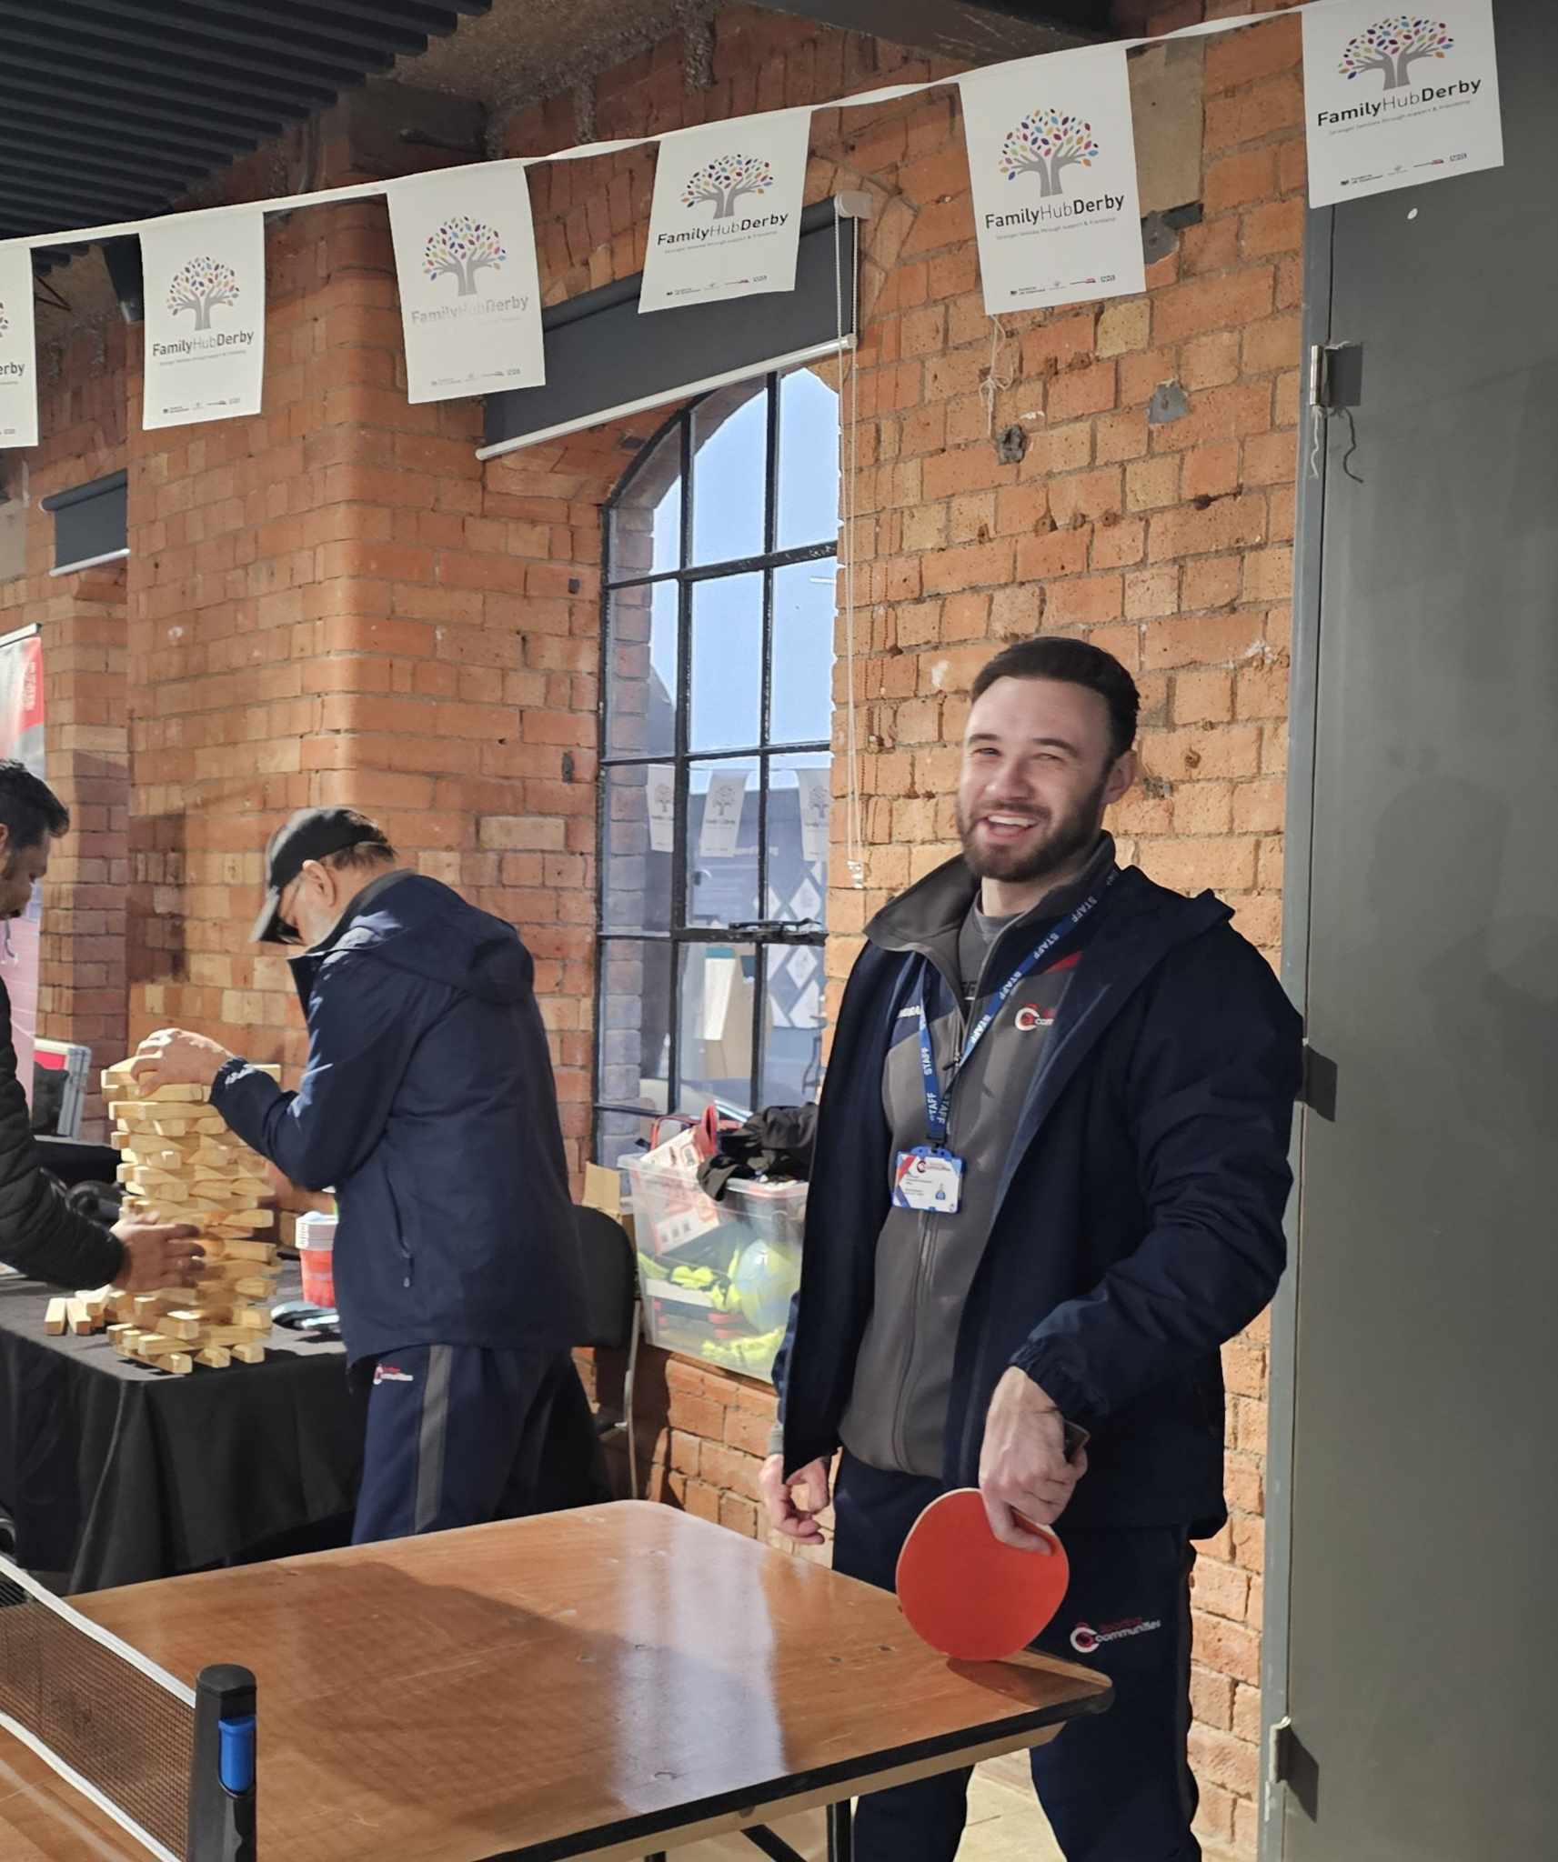
Supporting Communities
Supporting Communities did a fantastic job in engaging with the young people in their activities.
They offered several things for them to get involved such as Table tennis, Jenga and Connect 4. There was something for everyone to enjoy and it was great to see how much fun they all had during these activities!
Thank you, Ed and Lemar at Supporting Communities, for your attendance.

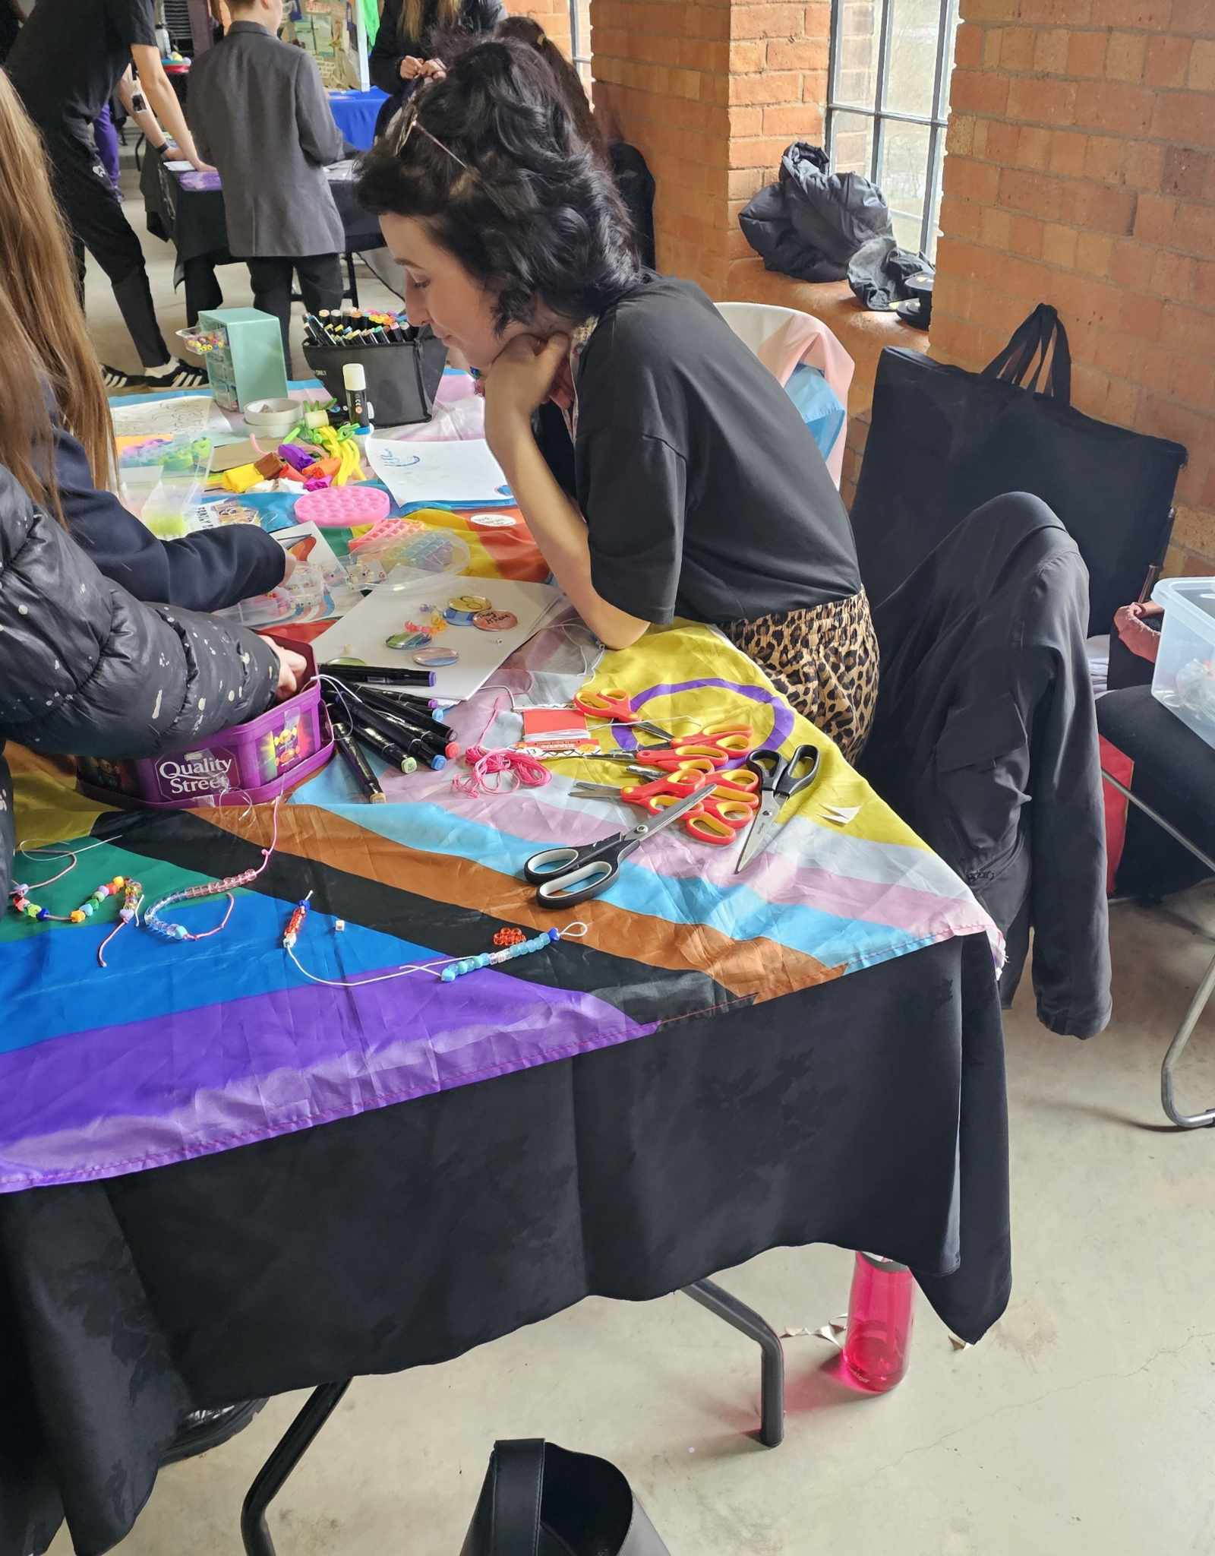
Derbyshire LGBT+
Derbyshire LGBT brought out the creative side for many young people and offered little craft activities such as bracelet making or colouring.
Their stand was vibrant and bright, which was so inviting for everyone passing by!
Thank you, Sonia, at Derbyshire LGBT+ for your attendance



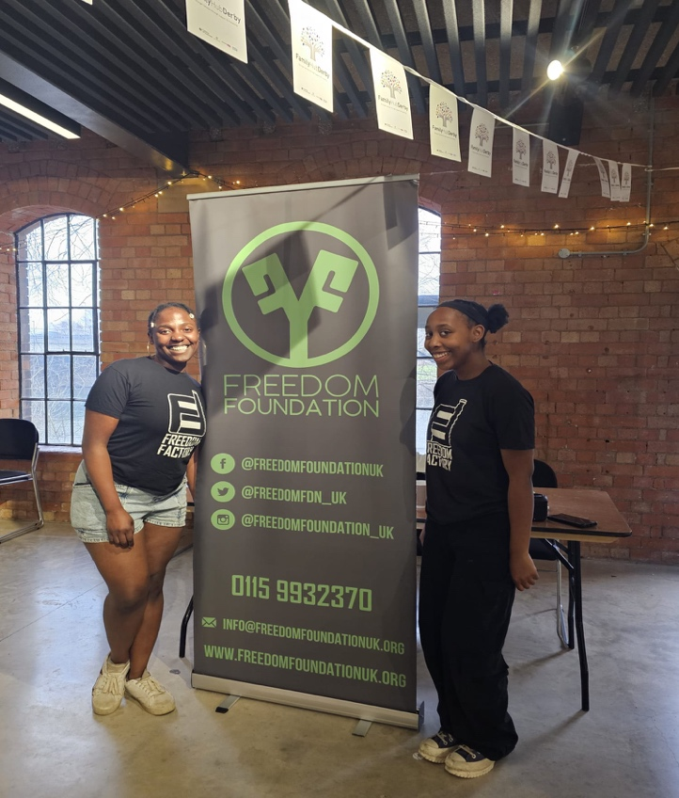
Freedom Foundation
Freedom Foundation delivered a dancing session to our young people with a great assortment of music which was so entertaining to watch.
By the end of the session, they had a few young people rehearsing their choreography!
Thank you, Anna and her team, at Freedom Foundation for your attendance.

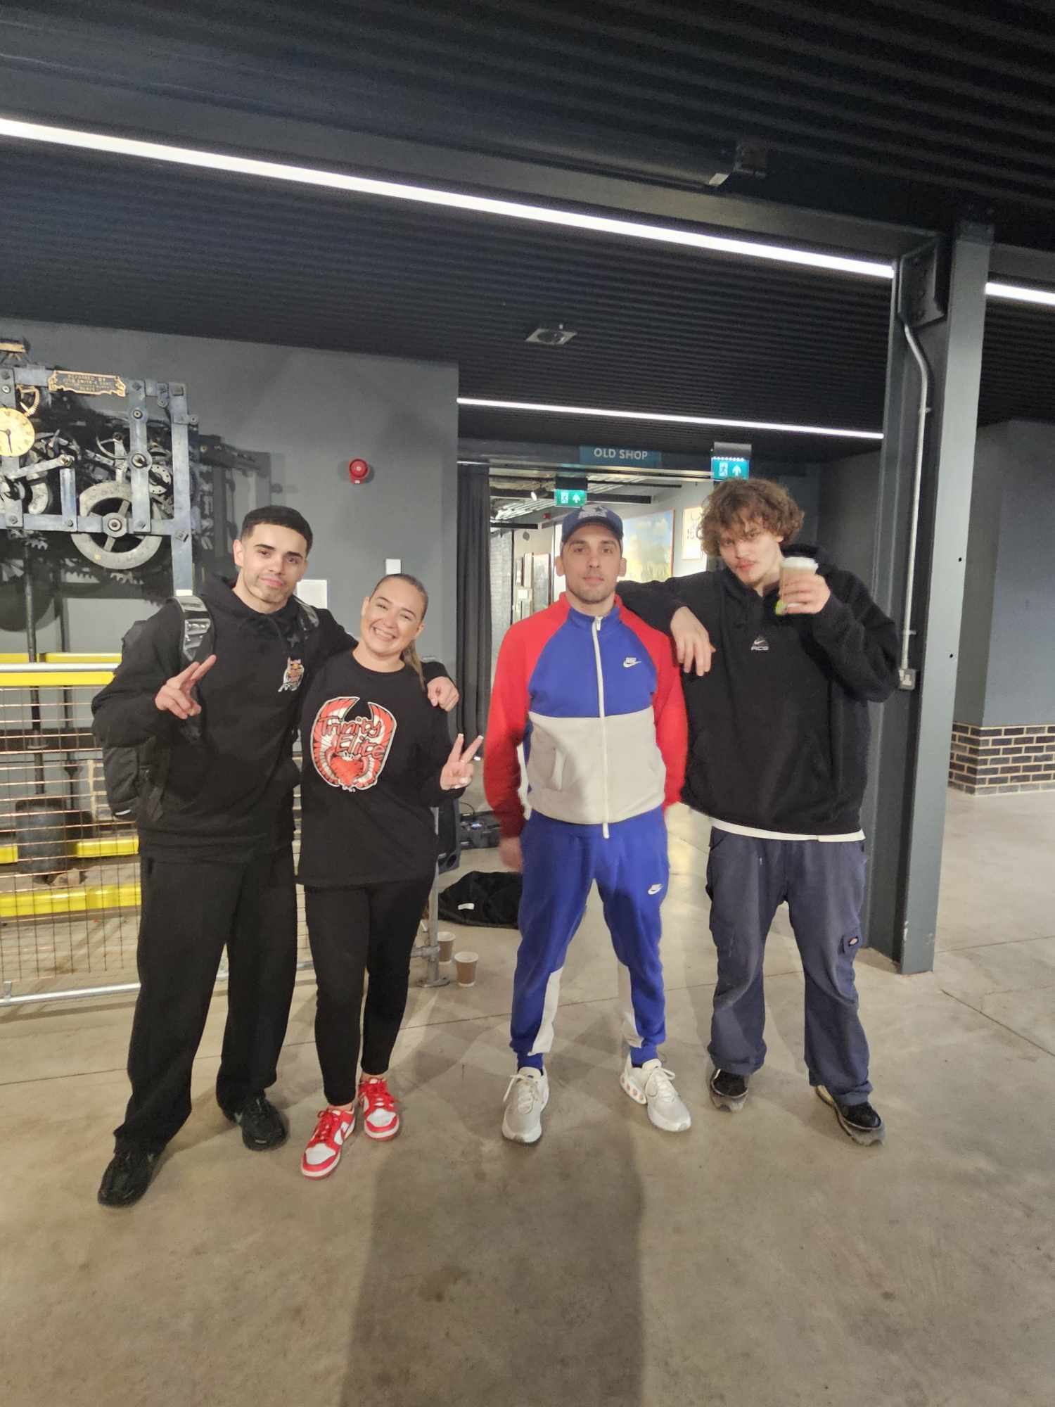
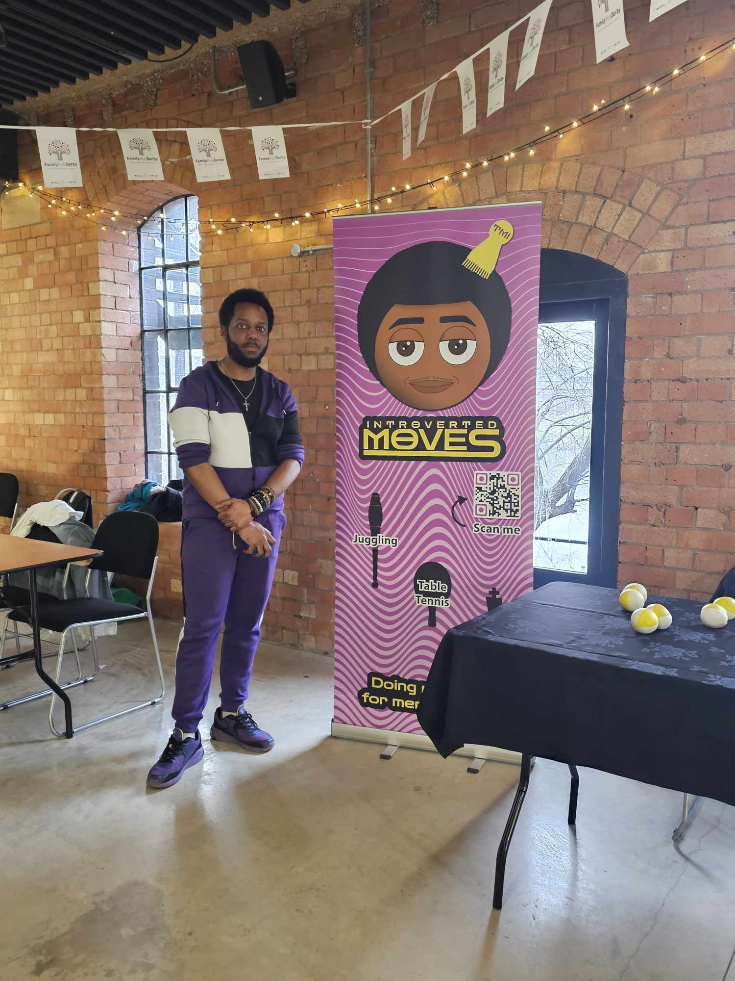
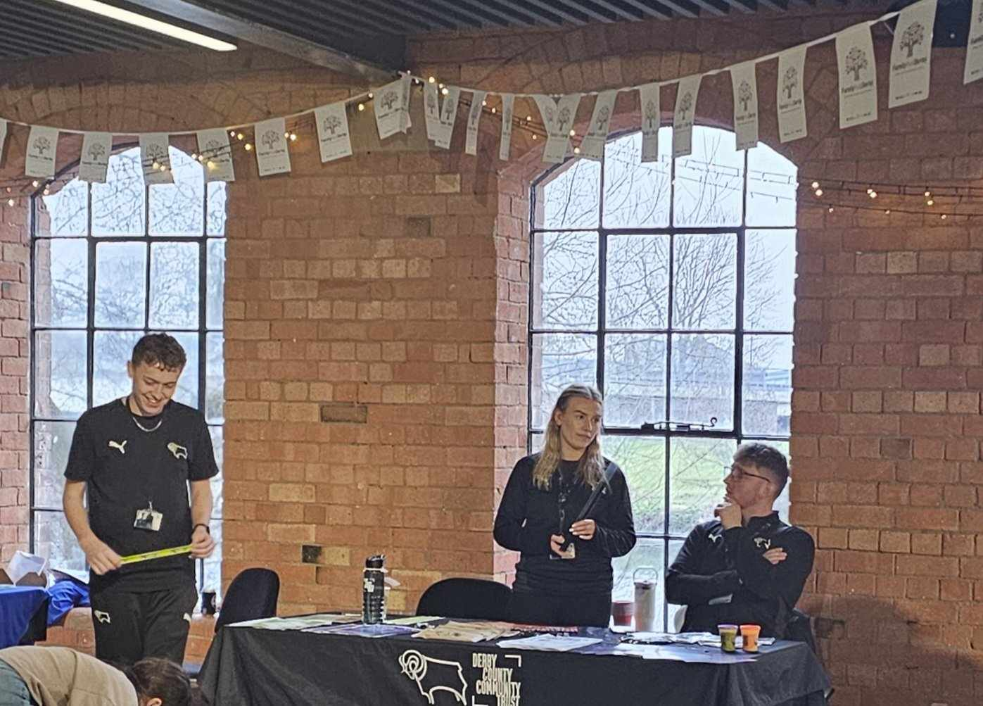
Derby County Community Trust
Derby Country Community Trust took the physical activity approach in their mini sports related indoor activity.
It was great to see the young people being active and enjoying the mini game created on the floor.
Thank you to Sharon and her team at DCCT for your attendance.
Trinity Warriors
We had the pleasure of two dancing activities available to us! Trinity warriors focussed on delivering a break-dancing session, which was very impressive to watch.
Some of the moves they were pulling off looked so fun for the young people to attempt!
Thank you to Paco and the team at Trinity Warriors for your attendance.

Introverted Moves
Introverted moves focussed on trying to teach the young children and even some of the adults how to juggle.
It was nice to see this was an activity which was of interest to the young people and the adults in the room too!
Thank you, Andre, at Introverted Moves for your attendance.

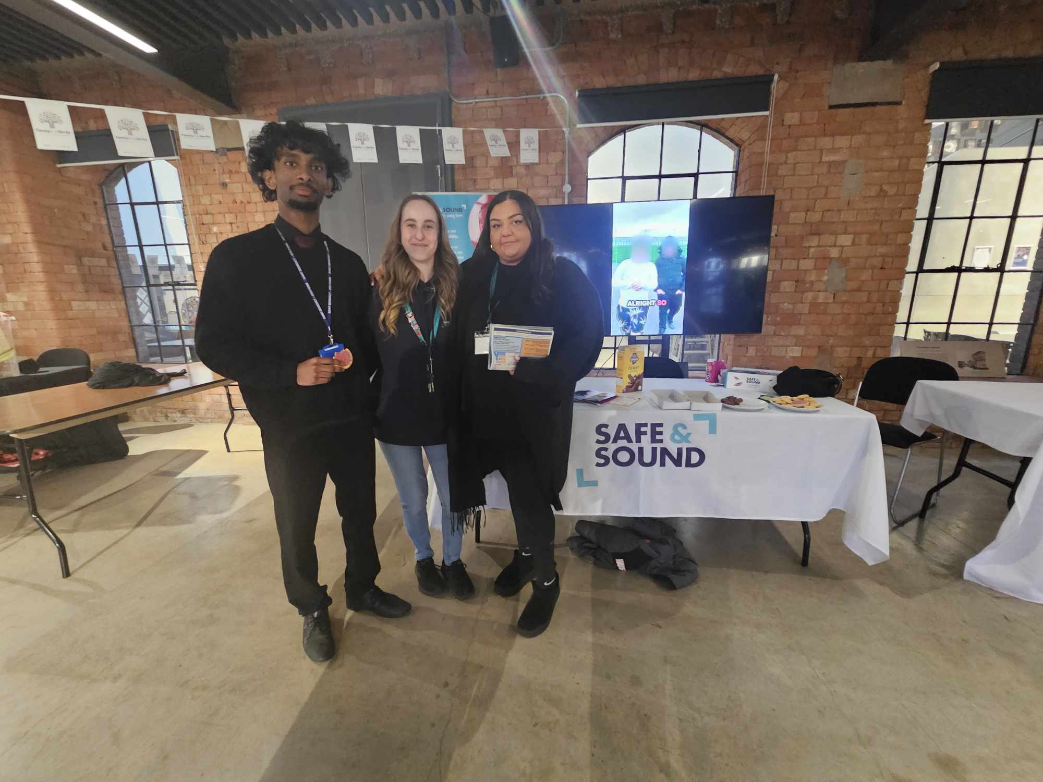
Safe and sound
Safe and sound were provided 2 screens to showcase the impact they have had on many young people and children.
They also provided an assortment of treats and snacks for the public to enjoy!
Thank you, Tracy, Fern and Katie, at Safe and Sound for your attendance.

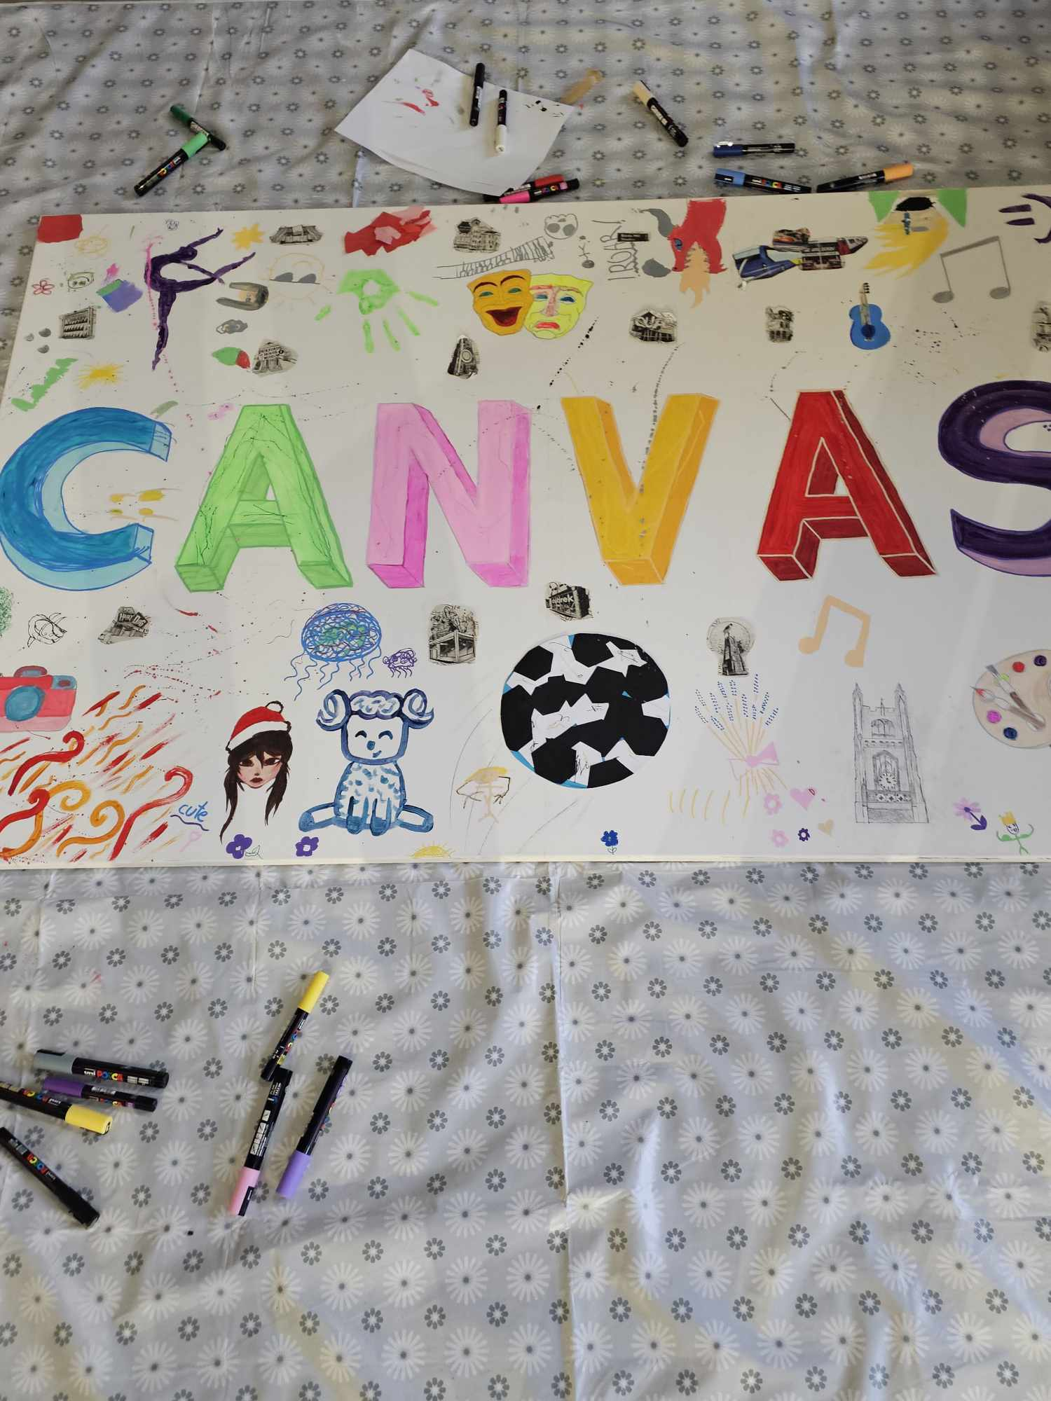
CANVAS
CANVAS gave the opportunity for all individuals to express themselves in whichever way they wished to.
So many children and adults gathered round the canvas to doodle and draw
The end result was a great representation of how differently we all use our imagination!
Thank you Rosie and Lauren at CANVAS for attending.
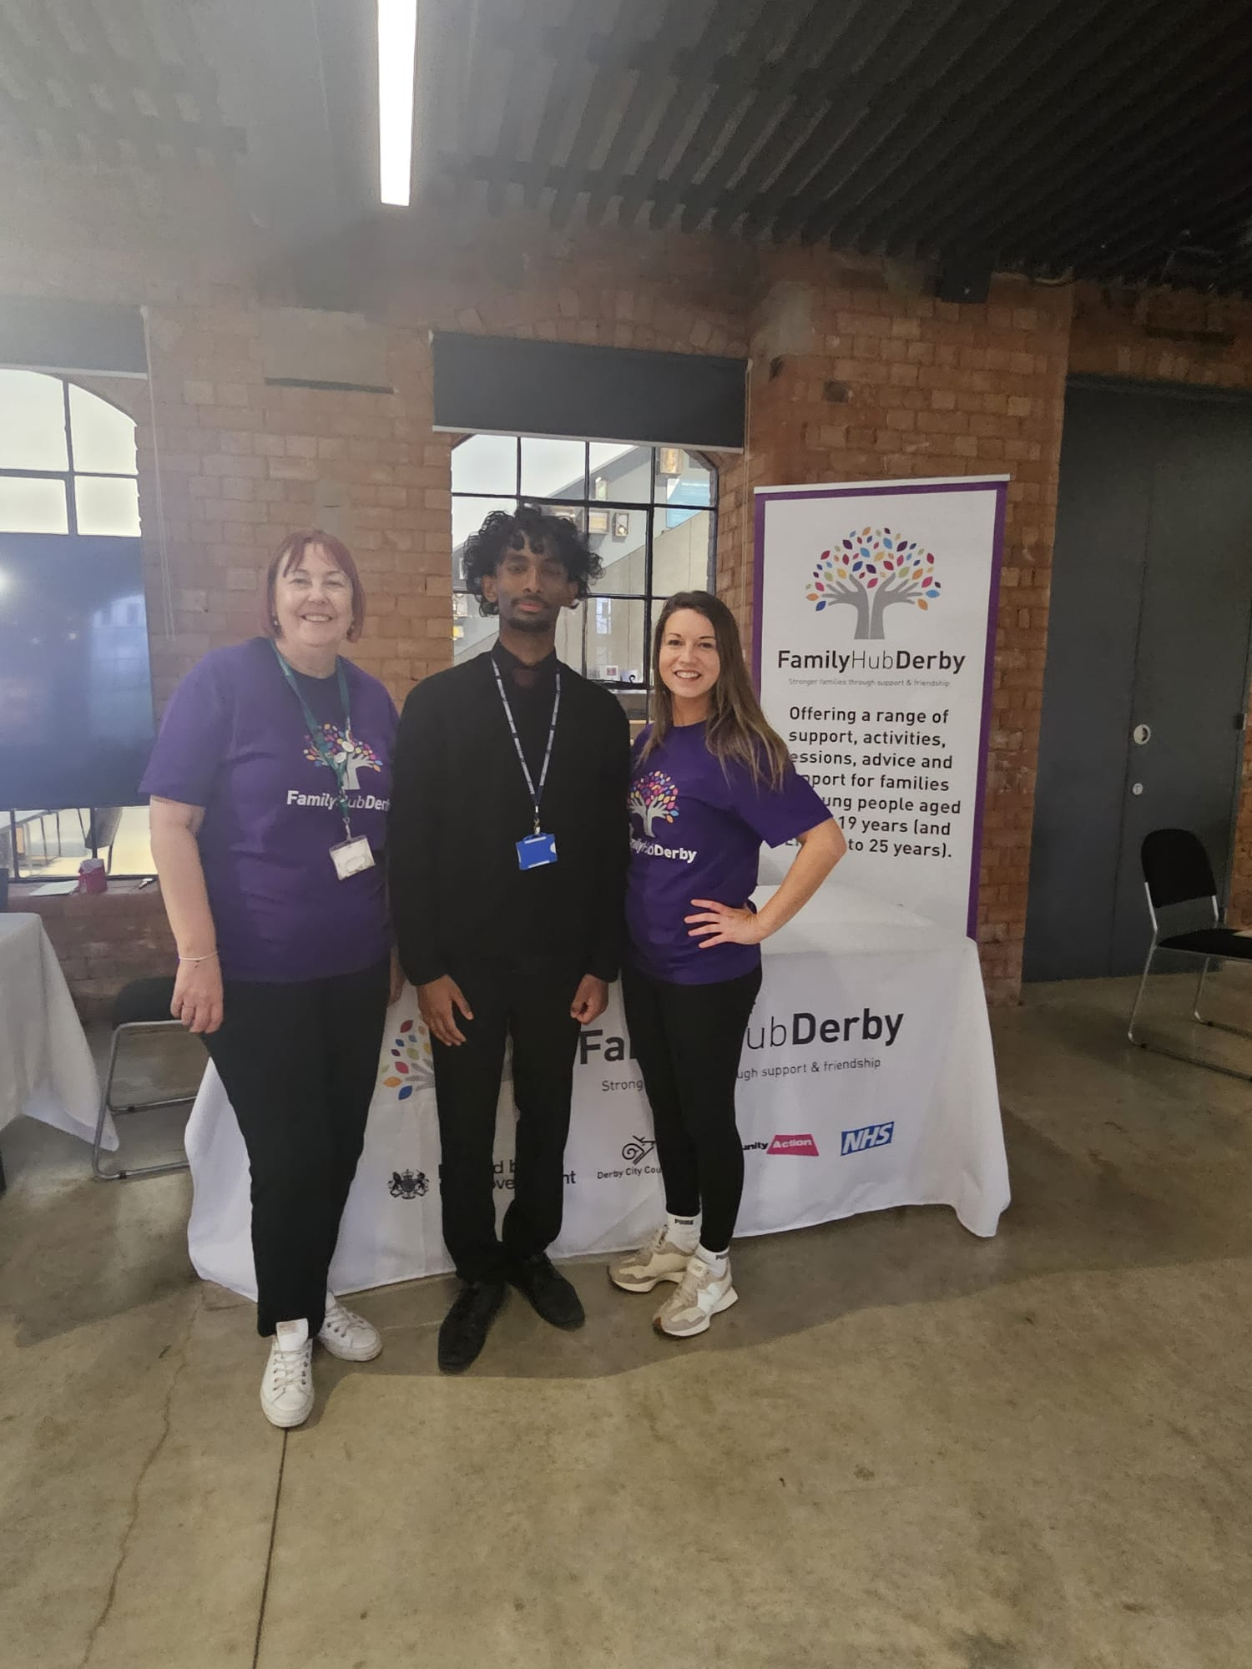
Additional thanks!
Thank you to Sam, the Youth Mayor of Derby for attending.
Thank you to Fiona, Alix and her team within Family Hubs for allowing us to be a part of this event.
Thank you to all the children, young people and the adults for attending our event.
Thank you to the Museum of Making and their team for providing us with an amazing venue to deliver this!

